Project Design Phase
Solution Architecture
Date | 18 February 2026
Team ID | LTVIP2026TMIDS57846
Project Name | Civil Engineering Insight Studio
Maximum Marks | 4 Marks

Architecture Overview
The CSS system follows a 3-Tier Architecture:

High-Level Solution Architecture Diagram
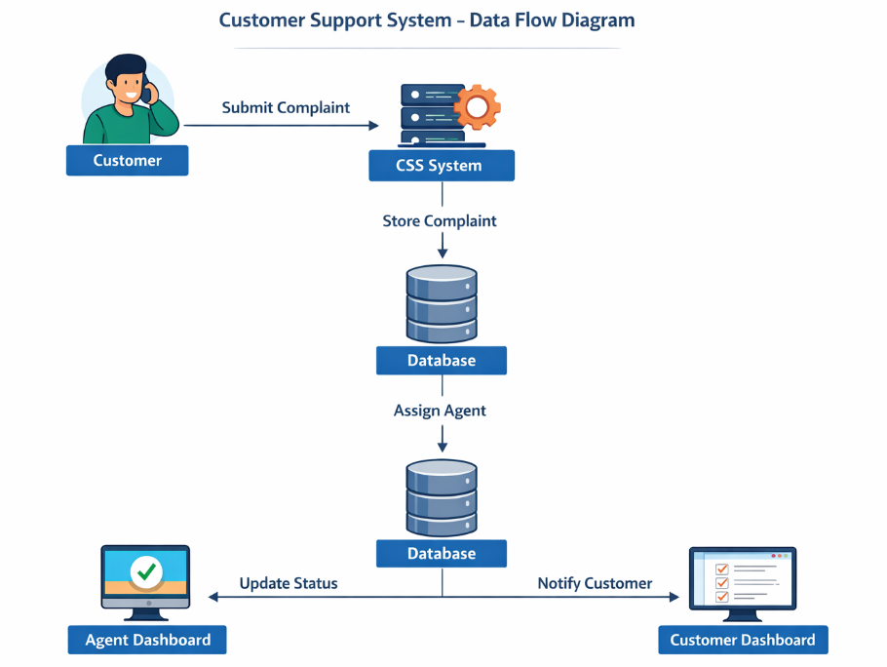

Detailed Component Architecture

1. Presentation Layer
- Login / Register Page
- Dashboard (Admin, Agent, User)
- Complaint Submission Form
- Status Tracking

2. Application Layer
- Authentication & Authorization
- Role Management (Admin, Agent, User)
- Complaint Assignment Logic
- Status Update Handling
- Email / OTP Confirmation
3. Data Layer
- User Table
- Agent Table
- Complaint Table
- Role Table
- Assignment Table

Technology Stack
Layer | Technology
Frontend | HTML, CSS, Bootstrap
Backend | ASP.NET Core MVC
Authentication | ASP.NET Identity
Database | SQL Server
Hosting | IIS / Cloud (Azure optional)

Deployment Architecture
Users (Internet)
│
▼
Web Server (IIS)
│
▼
Application Server (.NET Core)
│
▼
SQL Server Database

Security Architecture
User Login
│
▼
Authentication (Identity)
│
▼
Role-Based Authorization
│
── Admin Access
── Agent Access
── User Access
Security Features:
- Password Hashing
- Role-based access control
- Email confirmation
- Secure database access

